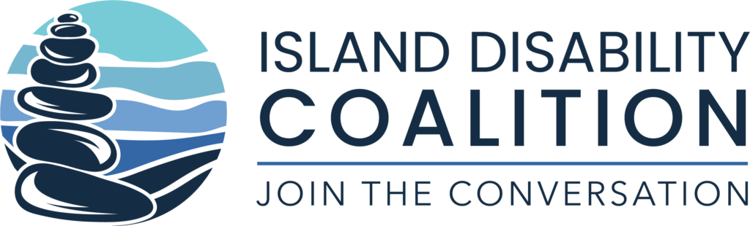

Inclusion Training and Consulting Application

Project Specifics:

Application Due: February 19, 2021. Email completed application to julielivelyidc@gmail.com
IDC Application Review: February 19 – March 5, 2021.
Process: Complete application below to outline the project and demonstrate your organizations commitment. Applications will be reviewed by the IDC Steering Committee and Stakeholder panel. A zoom meeting may be requested to further clarify the project.
Project Awards Notification: On or about the week of March 8, 2021

Project Timeframe: March 2021 – December 2021.
Project Parameters: Projects can be as simple as one session of training and/or consulting, to a more complex project that could take up to 6 months. Preference will be given to organizations that demonstrate the ability to incorporate what is learned into their culture on an ongoing basis. The IDC will work with the organizations to collect project inclusivity goals, current status and post project results. We will continue to partner with the organizations to collect feedback on the project results approximately 3-6 months after implementation.

Desired Outcomes:

- Sustainable, long term inclusive practices embedded within the organization that will withstand changes in leadership and staff
- Increase in organizational confidence and capacity to provide inclusive programming
- Development of Island best practices for inclusive programming
- Peer networking and sharing of project goals, process and results

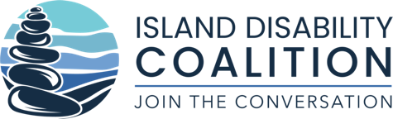

Inclusive Recreation and Leisure Training and Consulting Application:

Organization  Name |  | Date
Contact  Name |  | Email
Contact  Title |  | Phone

Organization Description:

Inclusive Project Description:

Anticipated Results: Please include at least one measurable goal that your organization can track and report at the end of the project.

IDC’s vision is a community that truly includes and supports people with disabilities and affords an opportunity for fulfilled lives. Please describe how your project aligns with this vision.

